Understand Linked Lists

Types of Linked Lists:
- Singly Linked List
  - Each node points to the next node.
  - One-way traversal.
  - Simple and memory-efficient.
- Doubly Linked List
  - Each node points to both next and previous nodes.
  - Allows two-way traversal, easier deletion from both ends.

Analysis:
Operation | Time Complexity | Explanation
Add | O(n) | Traverses to the end to add
Search | O(n) | Linear scan to match task ID
Traverse | O(n) | Visit every node
Delete | O(n) | Find and unlink the node

Advantages of Linked Lists over Arrays:
Feature | Arrays | Linked Lists
Size | Fixed | Dynamic
Insert/Delete | Complex (O(n)) | Efficient (O(1) if position known)
Memory | May waste space | Allocates as needed
Random Access | O(1) using index | O(n) (no index)

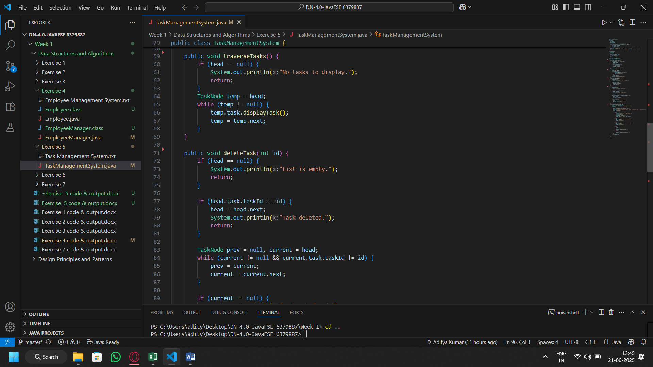
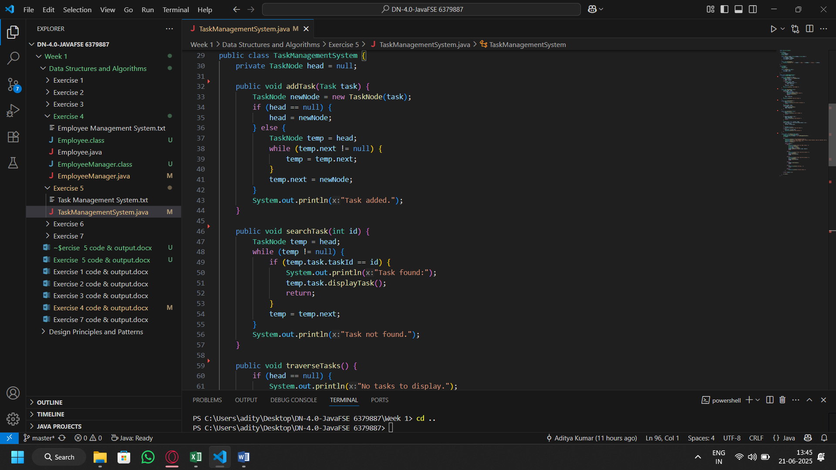
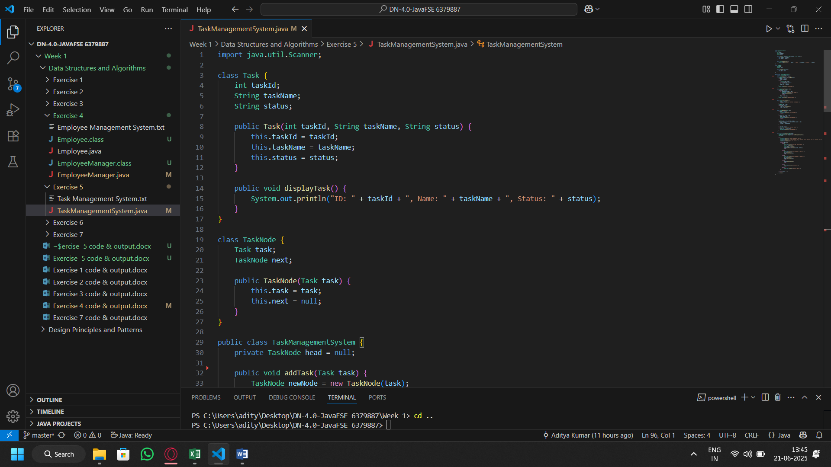
Code:

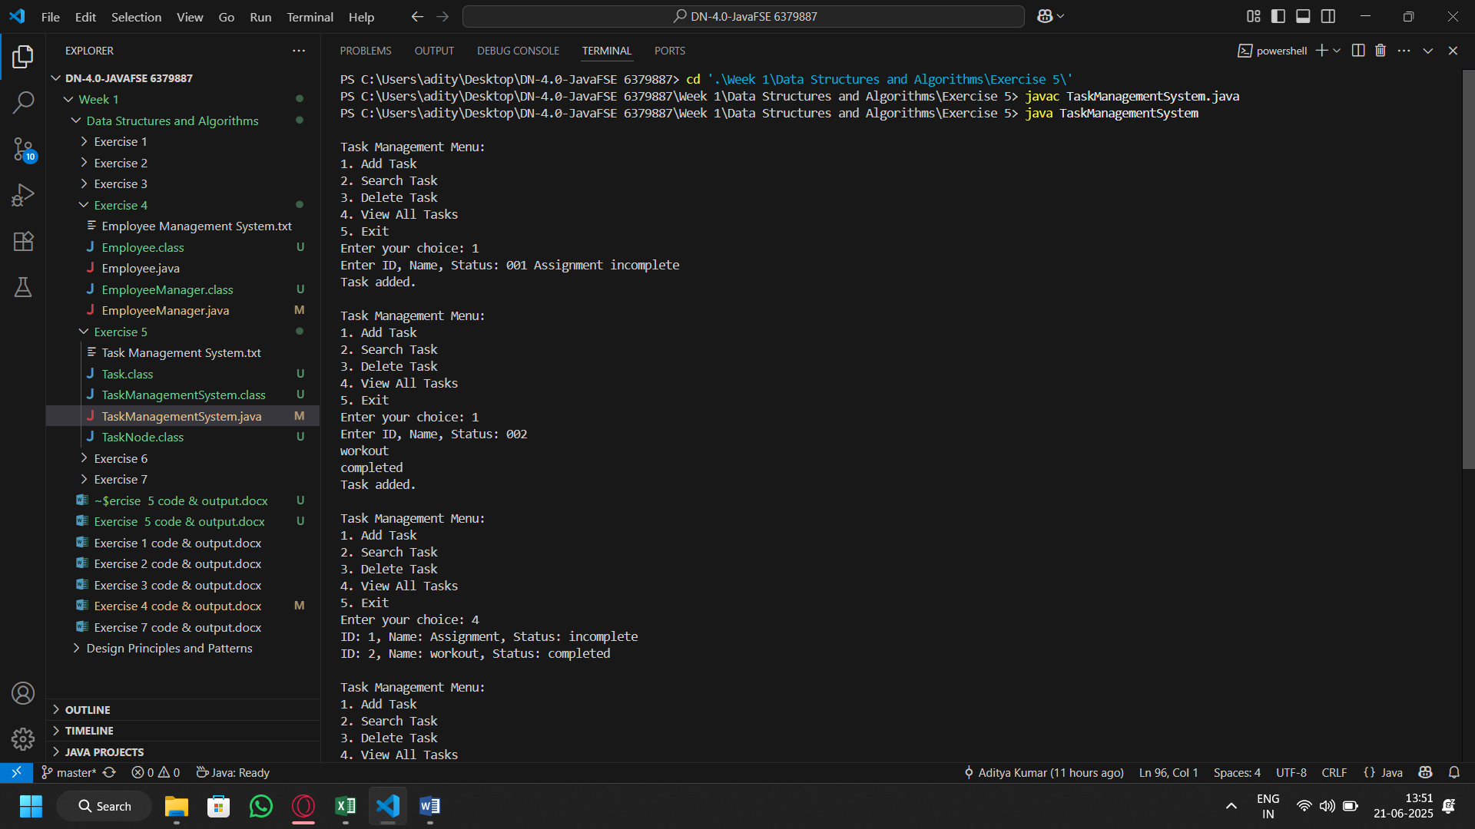
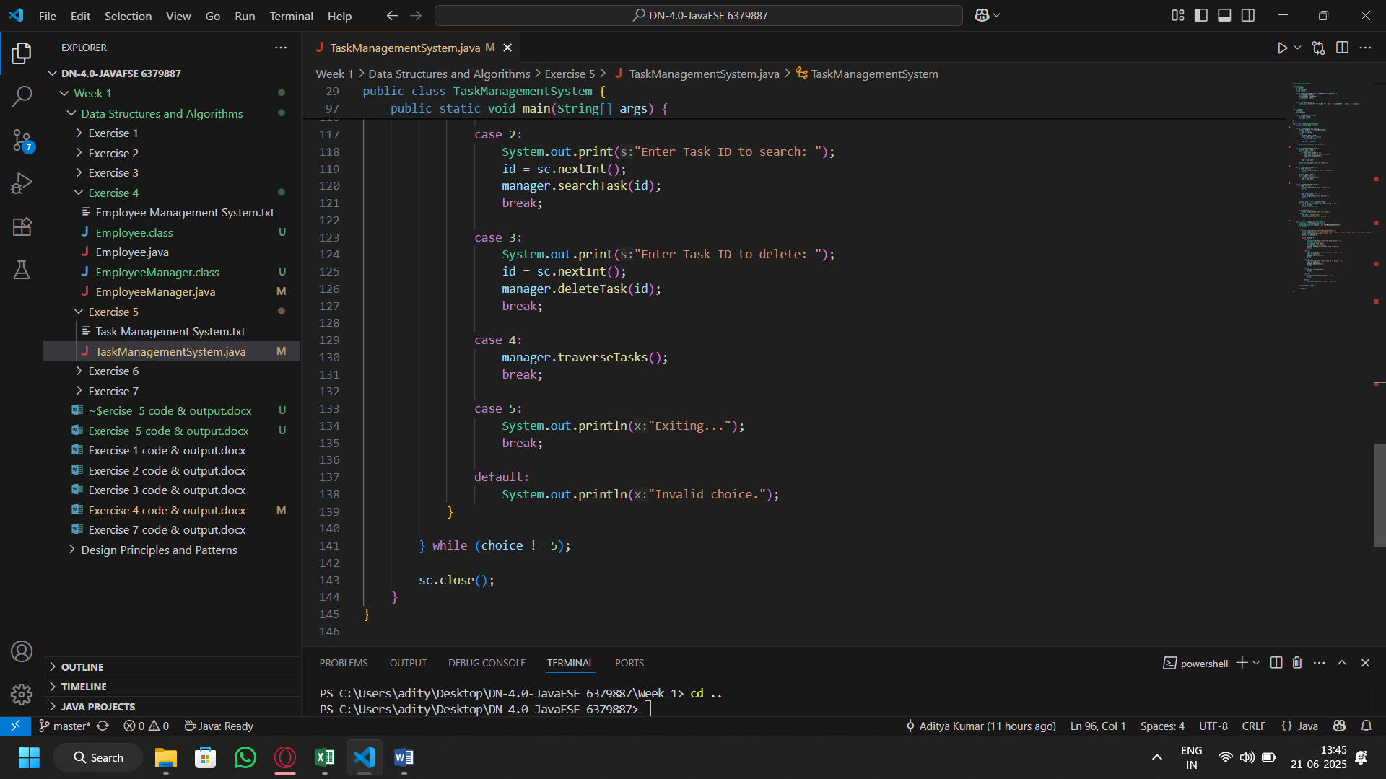
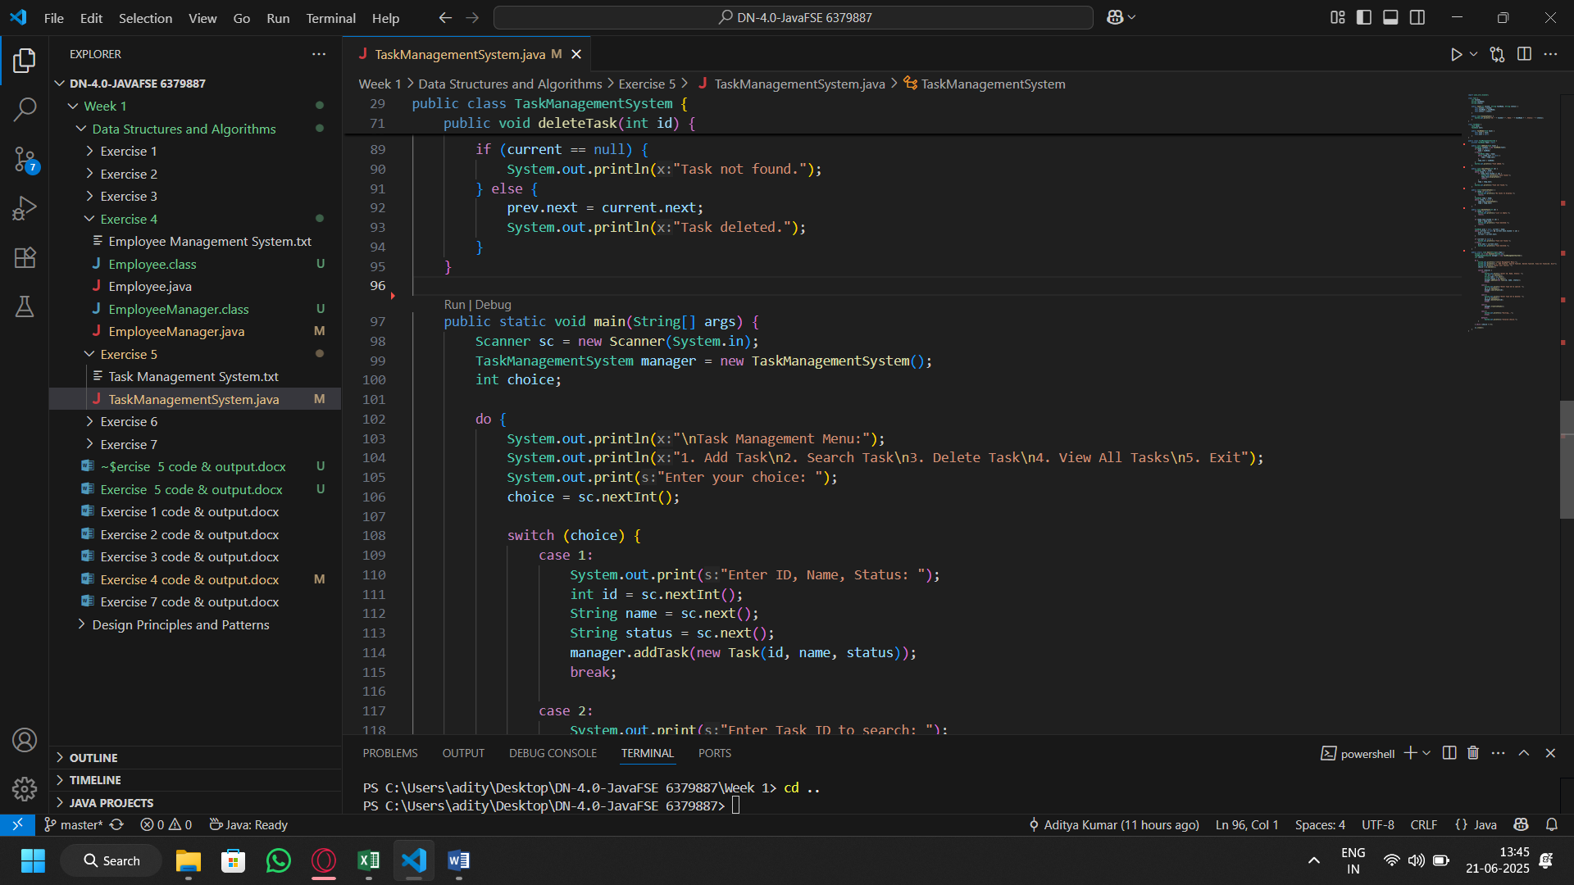
Output:

